Just a reminder that these are activities, not for academic assessment purposes. Many of these activities are educational and will fit in with our Manitoba Curriculum. ~ Ms. J. Bercier

Take them outside!
- Birds Hill Park trails
- Brokenhead Nature Trail
- Whiteshell Provincial Park
  - Identify different plants in their winter setting
  - Look for animal tracks – identify the tracks
  - Snowshoeing, skiing, walking
- Snowflake observation – use dark coloured cloth to catch the snowflakes and view the different designs with a magnifying glass or macro lens on a phone camera
- 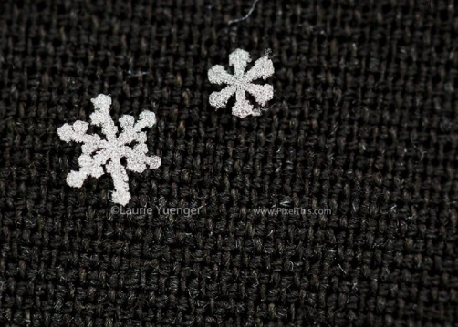
- Do rubbings – white paper and crayons – place the paper on tree bark and rub the crayon over it. Look for different textures
- Use fallen branches to create different types of structures – be creative!
- If the snow is just right:
  - snowball fight! (with rules!) – create games to throw the highest, farthest, targets etc
  - make snowmen! Be creative! Create different characters
  - snow sculpture – use paint to colour the snow
- Take pictures of frosted windows, snow on trees, light shining through the branches
- 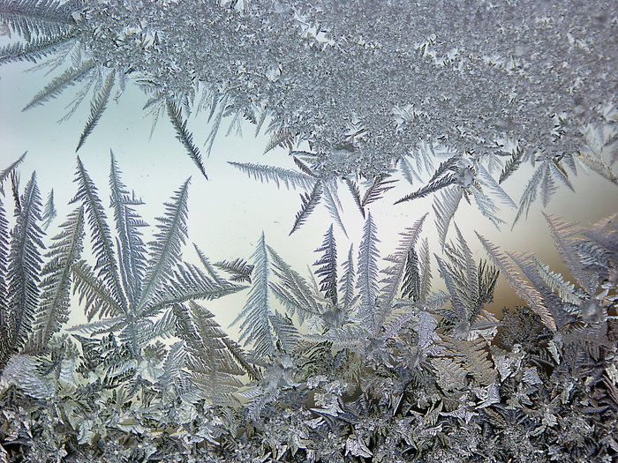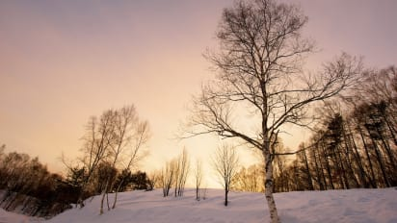
Buy seeds and plant starter kits! – grow plants at home! Watch them grow. Write a daily observational journal about the plants observing height, colour, length, sunlight availability, water content, environment etc. Talk to your plants! Encouraging kind words will help your plants to grow! Find out about a Three Sisters Garden!
- Tobacco seeds – phone/video chat/message a local Elder to find out more about the importance of tobacco in First Nation and Metis culture.
Find out more about the Four Sacred Medicines (tobacco, sweetgrass, sage, cedar) and their purpose – online, phone/video chat/message a local Elder to find out more.
Research about the types of Winter Medicines that are available right now from our native plants. Take pictures around on your nature walks.
Buy fabric and create fabric dolls – make it easy! Teach how to hand sew with needle and thread. Have children paint their design on the fabric once it’s sewn. They can tell stories with their new fabric dolls.
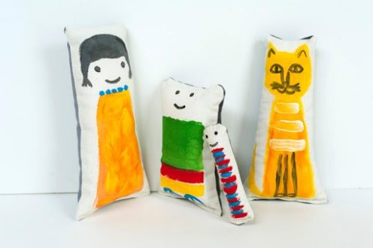
Collect stones – paint them with acrylic paint. Use these to tell stories.
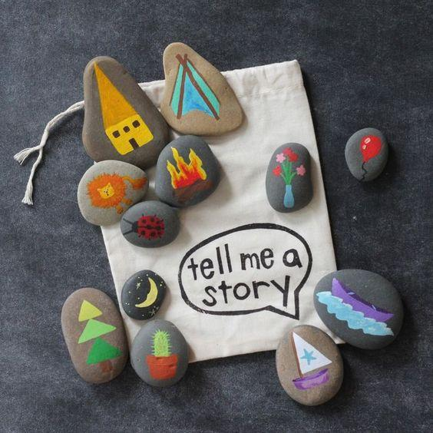
Tell stories! Read stories! Create a story!
Learn to smudge with your family – or why many First Nations and Metis people smudge: https://www.youtube.com/watch?v=6fIMumk2cnA
Learn to do beading crafts: https://www.youtube.com/watch?v=oQz-p2yzs74&t=1317s You’ll need small coloured beads, felt, thin beading needles and thread
Create dot art pictures with paint! Check out www.christibelcourt.ca for more inspiration about Metis Dot art. Use ends of pencils, lollipop sticks, toothpicks, skewers, end of a paintbrush etc in order to create little dots. Experiment with size, and colours. https://www.youtube.com/watch?v=sIyBkKl77Zk
Watch the night sky. Learn about the Cree names for constellations, and the stories attached to them. https://www.youtube.com/watch?v=WaOJIjyhIpg or the Elder Wilfred Buck introduction: https://www.youtube.com/watch?v=fd18NxiH_BQ
Download Skyview Lite app (free on iOS) to discover the different constellations and planets in our night skies.
Learn an Indigenous Language!
Michif: (Cree/French) - https://www.youtube.com/watch?v=qT5j7HWS3qI&t=94s (look at the other Youtube videos following this one for more Michif language.
Cree: Counting 1-10 - https://www.youtube.com/watch?v=02PHMfA3RFM&t=1s
Ojibway: Introductions - https://www.youtube.com/watch?v=dBvYGALiSgA
Learn about some of the teachings behind many of our Ojibwe words through James Vukelich’s Ojibwe Word of the Day: https://www.youtube.com/watch?v=ElcZ3hwfCm8&t=38s
Visit your local library (if they are allowing visitors) – Sign out books on “The Indian Group of Seven” – find out more about these amazing Indigenous artists: Norval Morrisseau, Daphne Odjig, Alex Janvier, Bill Ried etc.
Library books – ask about Indigenous authors – there are so many to choose from! Different topics of First nation traditions, stories, plants, teachings etc.
Learn to cook some Indigenous contemporary meals with your children! Learn the names of each ingredient, or the meal name in an indigenous language.
Indigenous Contemporary Recipes:
Metis Boulette Soup
Bannock (frybread, oven bannock, bannock on a stick etc)
Rubbaboo Soup
Popped Wild Rice
Beef Stew (If you can use Elk, Bison or Moose meat for your stew)
Three Sisters Soup
Metis Tacos with Frybread!
Blueberries and honey
Rice Pudding
Baking powder biscuits
Make tea and visit with each other!

Learn some songs! Ojibwe children songs (Nagamonan Compilation) https://www.youtube.com/watch?v=TrlZYuUL9HI&list=PLdwZR4IMCngZShDHxVXOyKxF-6CaK_SPp

Learn some powwow dance moves and exercise! Check out the Powwow Sweat compilation
https://www.youtube.com/watch?v=ZhfglbhKCo0&list=PL6bNa81aVS4S3dl7Iii2QSK0BShDRUS8P

Learn about the importance of WATER – Read Nibi’s Water Song, learn the Water Song (Wishatinaya) https://www.youtube.com/watch?v=C6usG5PlIs0&list=PLdwZR4IMCngasAecatqxWXDitCEVY56iy&index=12&t=0s , learn about Water Protectors and the role of Women as Water Protectors.
Create different coloured patterns for a Starblanket: Story of the Star Blanket https://www.bsd.ca/schools/Jrreid/News/January2014/Documents/Star%20Banket%20Ceremony.pdf
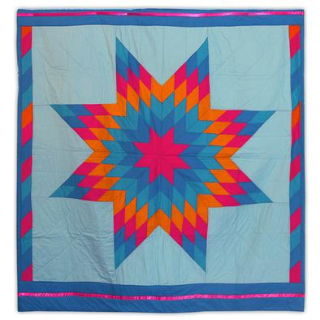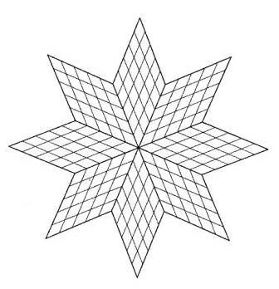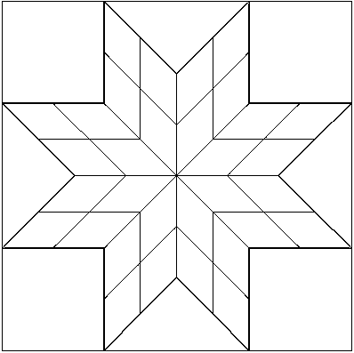

Learn about Treaties and how it applies to you! http://www.trcm.ca/
Check on your Elders, grandparents, family members that cannot go out on their own. Pick up groceries for them. Drop off baking, reheatable meals. Help them with cleaning, or yardwork. If you’re sick, just call them to check on them. Let them know you are thinking of them.

